Test Case: tc001_SPX_Dev5_Crear_Solicitud_Articulo_Almacen
Step 1 - Enter username and password and click to button Enter : Credentials Entered
Image file-name: QC_Testing-tc001_SPX_Dev5_Crear_Solicitud_Articulo_Almacen-1787932739193

Step 2 - Select to UEN and Access to Request for a New Inventory Item : UEN Correctly selected and Correct access
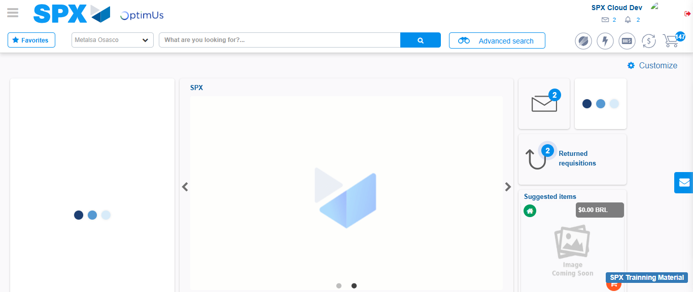Image file-name: QC_Testing-tc001_SPX_Dev5_Crear_Solicitud_Articulo_Almacen-1787932765487

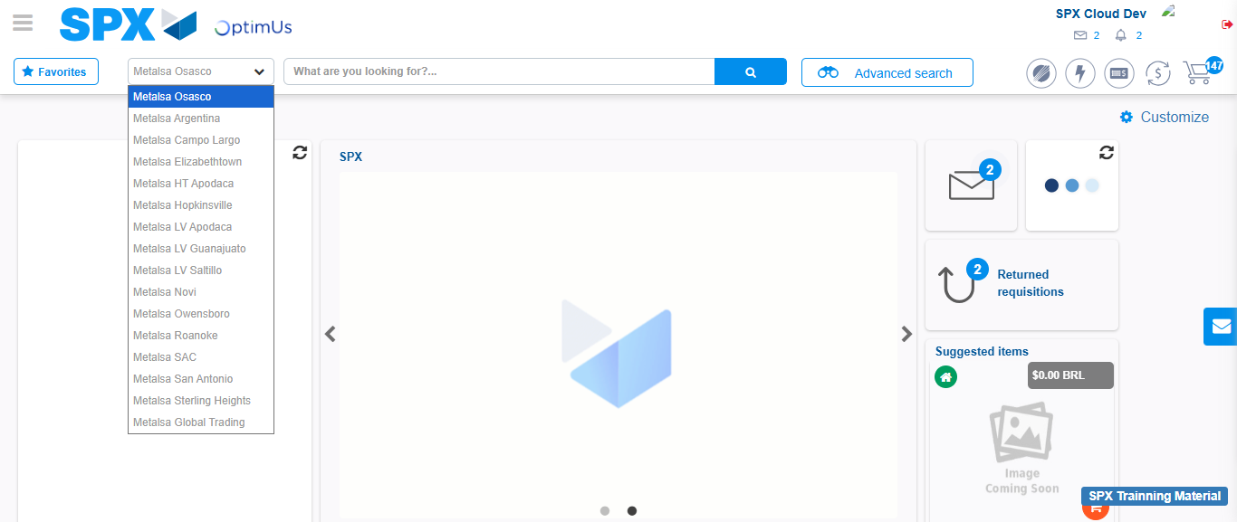Image file-name: QC_Testing-tc001_SPX_Dev5_Crear_Solicitud_Articulo_Almacen-1787932766066

Image file-name: QC_Testing-tc001_SPX_Dev5_Crear_Solicitud_Articulo_Almacen-1787932788899

Step 3 - Select options first section : Options seleted correctly
Image file-name: QC_Testing-tc001_SPX_Dev5_Crear_Solicitud_Articulo_Almacen-1787932789144

Image file-name: QC_Testing-tc001_SPX_Dev5_Crear_Solicitud_Articulo_Almacen-1787932789258

Step 4 - Select options at Screen: Options seleted correctly
Image file-name: QC_Testing-tc001_SPX_Dev5_Crear_Solicitud_Articulo_Almacen-1787932789144

Image file-name: QC_Testing-tc001_SPX_Dev5_Crear_Solicitud_Articulo_Almacen-1787932789258

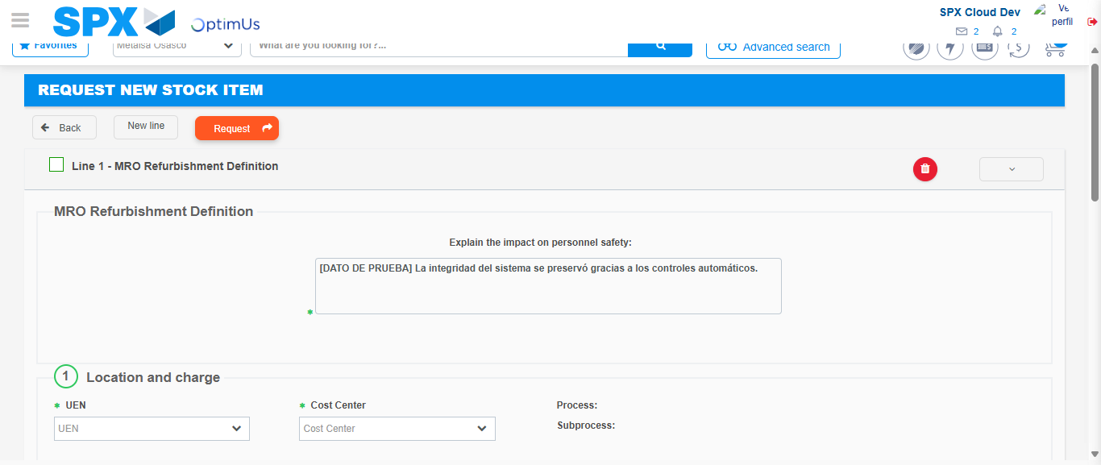Image file-name: QC_Testing-tc001_SPX_Dev5_Crear_Solicitud_Articulo_Almacen-1787932795521

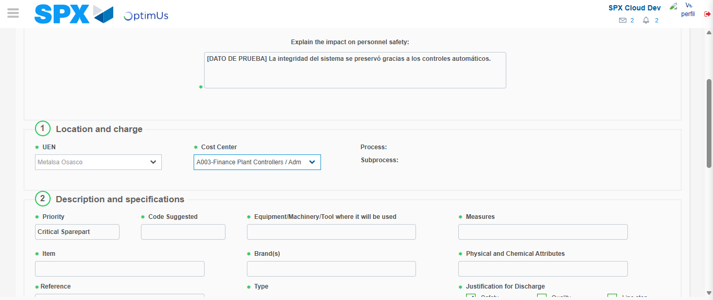Image file-name: QC_Testing-tc001_SPX_Dev5_Crear_Solicitud_Articulo_Almacen-1787932798223

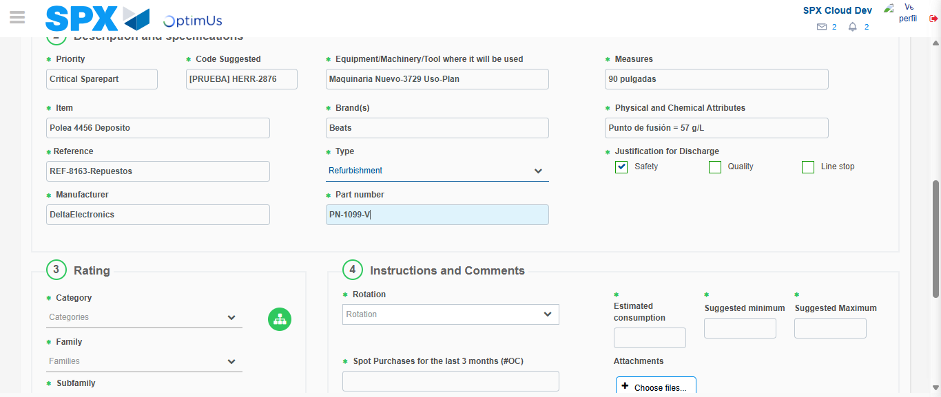Image file-name: QC_Testing-tc001_SPX_Dev5_Crear_Solicitud_Articulo_Almacen-1787932799926

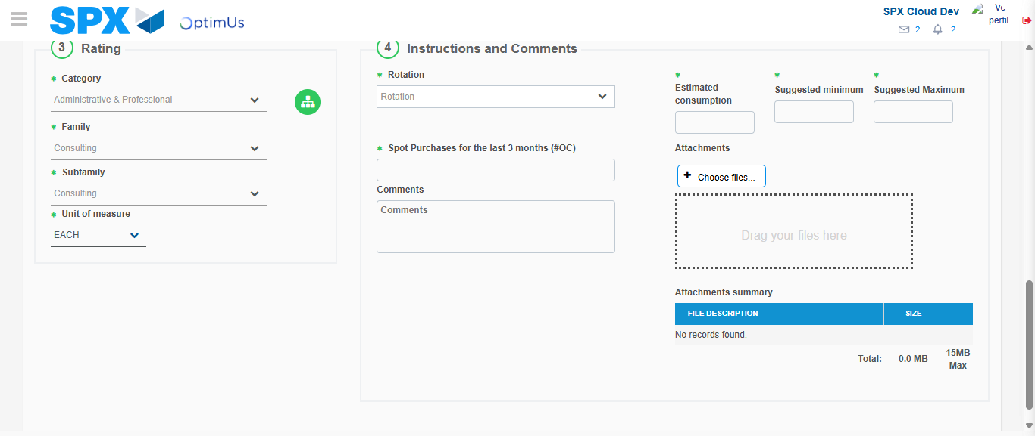Image file-name: QC_Testing-tc001_SPX_Dev5_Crear_Solicitud_Articulo_Almacen-1787932804989

Step 5 - Request New Item : Request Accepted
Image file-name: QC_Testing-tc001_SPX_Dev5_Crear_Solicitud_Articulo_Almacen-1787932765487

Image file-name: QC_Testing-tc001_SPX_Dev5_Crear_Solicitud_Articulo_Almacen-1787932766066

Image file-name: QC_Testing-tc001_SPX_Dev5_Crear_Solicitud_Articulo_Almacen-1787932788899

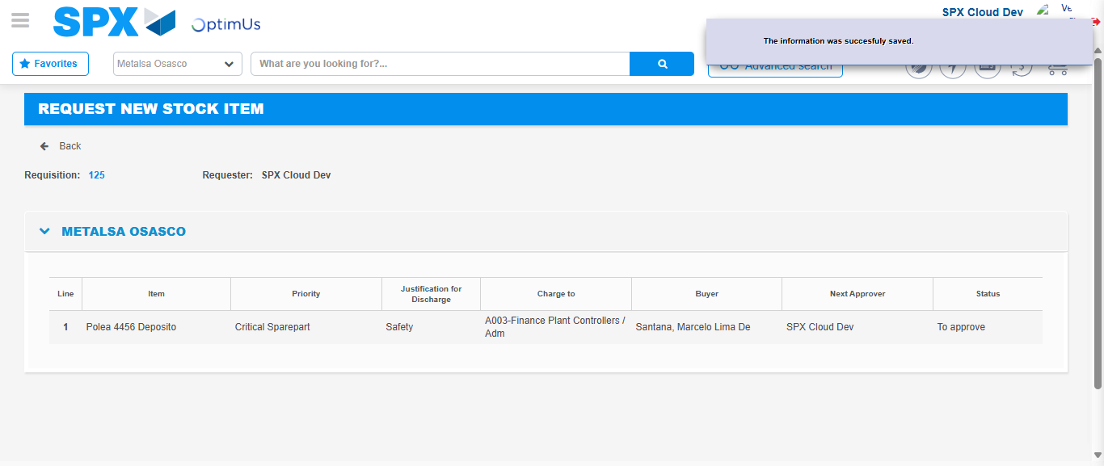Image file-name: QC_Testing-tc001_SPX_Dev5_Crear_Solicitud_Articulo_Almacen-1787932812115

Image file-name: QC_Testing-tc001_SPX_Dev5_Crear_Solicitud_Articulo_Almacen-1787932812248

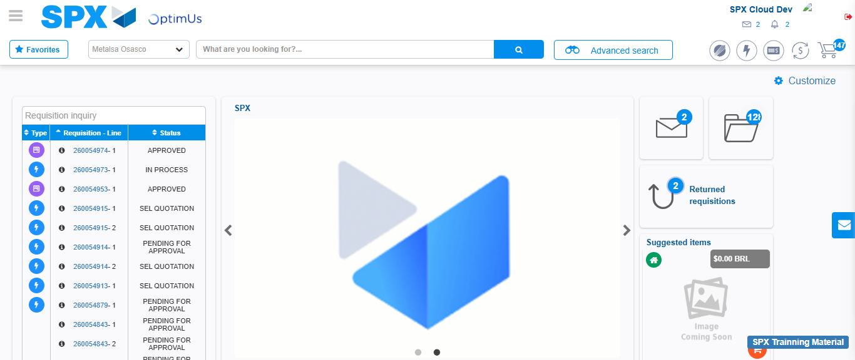Image file-name: QC_Testing-tc001_SPX_Dev5_Crear_Solicitud_Articulo_Almacen-1787932833455

Step 7 - Return to Main Page SPX : Return to Main Page SPX
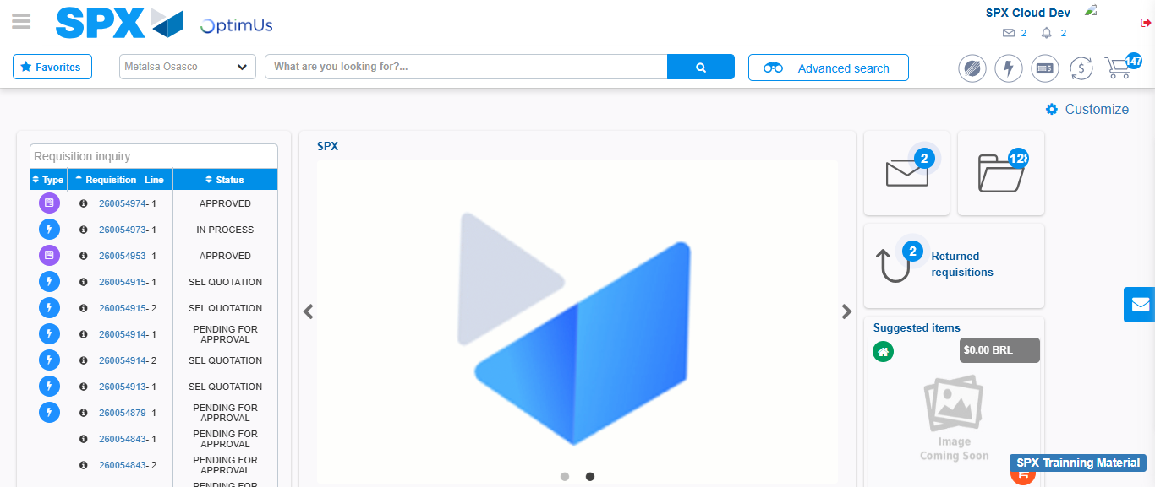Image file-name: QC_Testing-tc001_SPX_Dev5_Crear_Solicitud_Articulo_Almacen-1787932833721

